COMMITTEE

FOR TYTUS FILIPOWICZ AWARD
created in 2018 on the 100th anniversary of the restoration of the Poland's and Georgia's sovereignty announces recruitment of candidacies for the Award
FOR ACADEMIC YEAR 2021/2022
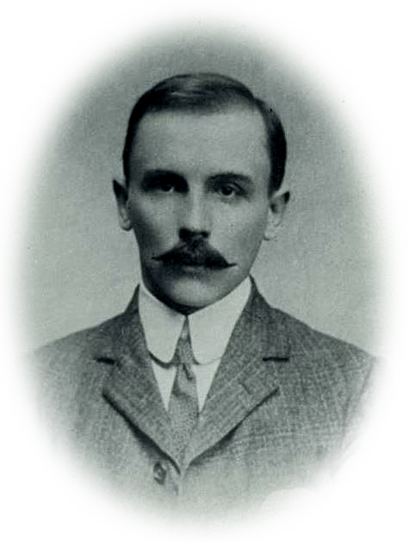
Tytus Filipowicz (1873-1953)

TYTUS FILIPOWICZ AWARD
a 10-month scientific and didactic stay at Polish higher education institutions for the candidate in the field of the humanities or social sciences
and

5 TRAINEESHIPS RELATED TO THE AWARD
- monthly research stays at Polish higher education institutions for candidates in the field of:
– social sciences,
– exact sciences,
  - – economic sciences,
– technical sciences,
  - – the humanities.
The programme is funded jointly by the Polish universities and scientific centres
Applications containing the description of the contributions and achievements of candidates
are to be sent to the Centre for East European Studies by 31 March 2021
at stypendia.studium@uw.edu.pl

- DESCRIPTION
The Tytus Filipowicz Award aims to honour the contributions of citizens of Georgia and Caucasus to the development of science, culture and public life, to the shaping and development of the civic society and to the construction of the democratic state of Georgia and the Caucasian countries – directed towards Europe, taking into consideration the historical, present and future ties with Poland and Europe.

The award was introduced in 2018 by the Centre for East European Studies at the University of Warsaw (initiator) and the following higher education institutions: Gdańsk University of Technology, Poznan University of Technology, University of Lodz, Maria Curie-Skłodowska University, University of Rzeszów, University of Warsaw and the Ossoliński National Institute as well as the College of Eastern Europe in Wrocław.

The award was introduced in 2018 by the Centre for East European Studies at the University of Warsaw (initiator) and the following higher education institutions: Academy of Fine Arts in Kraków, Gdańsk University of Technology, Poznan University of Technology, University of Lodz, Maria Curie-Skłodowska University, University of Rzeszów, University of Warsaw and the Ossoliński National Institute as well as the College of Eastern Europe in Wrocław.

Laureate of the Award
a candidate from the field of widely understood humanities receives the opportunity of a year-long scientific stay in 5 consecutively visited Polish universities where her or she can deliver lectures related to the history or present of the Caucasus and the Polish and Caucasian relations as well as take on his or her own archiving work.

Traineeship
related to the Award allows researchers from the fields specified on page 1 to take part in a 2-month research stay in a Polish higher education institution.

CANDIDATE QUALIFICATION
- The intake of candidates for the Award starts on 31 December 2020.
- Candidates can be registered by 31 March 2021.
- At a special meeting, the Committee will make a decision on whom the Award will be granted.
- The programme starts in October of the year when the Award is granted.

OBLIGATIONS OF THE HIGHER EDUCATION INSTITUTION
- scholarship – PLN 3500 net per month (if the laureate or a trainee holds the scientific title of habilitated doctor or professor); – PLN 2500 net per month (if the laureate or a trainee holds the scientific title of master or doctor),
- very good housing conditions throughout the stay in the given higher education institution,
- ensured scientific supervision/assistance of a tutor dealing with the field of the Laureate at each of the higher education institutions,
- books from the publishing house of the host universities, dealing with the field of the Laureate,
- Polish language course if needed.

OBLIGATIONS OF THE LAUREATE/TRAINEE
- 2 months of stay in each of the universities,
- delivery of one public lecture and possibly six course-related lectures in the institute of affiliation (as decided by the higher education institution),
- report on the stay,
- if the stay of the Laureate/Trainee bears fruit in the form of publications – the Laureate/Trainee will be obliged to include information on the Award in them.

