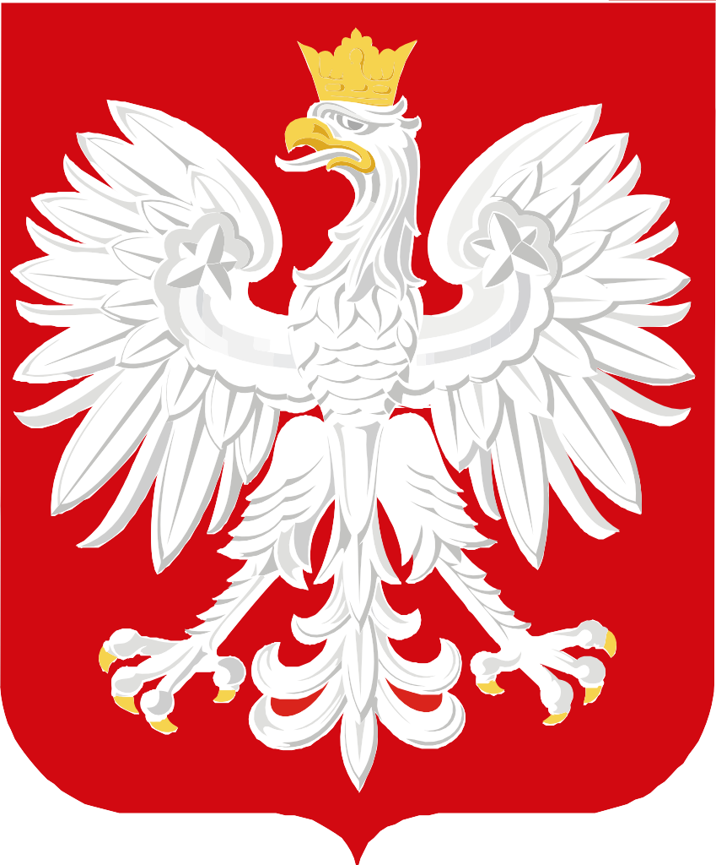

Scholarship Programme of the Government of Poland for Young Scientists
19th edition
academic year 2021/2022
for candidates from: Eastern Europe, Russia and Central Asia and Caucasus countries
The scholarships will be intended for a research stay at Polish higher education institutions
in the period from September 2021 to June 2022
Terms and scope of the scholarship and requirements for the candidates
– see in the folder or at www.studium.uw.edu.pl

CANDIDATES
- The "Scholarship Programme for Young Scientists," initiated in 2003, is addressed to candidates from: Belarus, Ukraine, Moldavia, Russia, Kazakhstan, Kyrgyzstan, Tajikistan, Turkmenistan, Uzbekistan as well as Armenia, Azerbaijan and Georgia. In the academic year of 2021/22, the 19th edition of the Programme will be held.
- Preferred are the candidates who have already had some scientific achievements and/or organisation activity and whose former activity gives the highest hopes of being the vehicle for using the specialisation acquired in Poland in their countries, in various disciplines of scientific life and social activity.
- Scholarships are granted to further the research project as part of the scientific traineeship.
- Each qualified candidate can obtain the scholarship once for a specific time which cannot be extended save for extraordinary circumstances.
- The total duration of the traineeship and the language course is 10 months, and the stay can be extended by one month, July 2022, if the programme coordinator applies for such an extension having consulted the tutor. The terms are specified in the Agreement and the Rules of the Programme. The possible extended scholarship will end on 31 July 2022.
- The people with the satisfactory knowledge of the Polish language will start the programme on 1 September 2021 with the Preparatory Course at the University of Warsaw, which will include general lectures and a supplementary course in the Polish language.
- In the case of scholarship holders accepted for the traineeship who have very poor knowledge of Polish, the Programme will start on 1 August 2021 with a introductory language course. In such a case, the scholarship can last even 12 months in total.
- The scholarship (studies) at the already assigned specific higher education institutions will start on 1 October 2021
and will end on 30 June 2022.
- The scholarship amount is PLN 1500.00 net. The scholarship holders use this amount to cover their lodging, board and insurance. Upon arrival, the scholarship holders sign an agreement defining the terms and conditions of payment of the scholarship as well as the rights and duties of the parties.
- The scholarship amount is paid only to the people who remain in Poland during the scholarship and who do not collect any other scholarship amounts.
- The full set of documents has to be submitted personally, sent by mail (with the following annotation on the envelope: "Scholarship Programme for Young Scientists") to the missions of Poland of proper venue or sent by e-mail at stypendia.studium@uw.edu.pl by 1 March 2021
- The competent consulates of the Republic of Poland will grant visas valid until 31 July 2022 to the people who receive the scholarship.

GENERAL REQUIREMENTS
- Completed higher studies (4- or 5-year studies ending with the defence of the Bachelor's thesis, the diploma thesis or the Master's thesis), first and foremost with the major in the humanities: history, international relations, political sciences, journalism, sociology, ethnology, cultural studies, social psychology, administration and management, law and related majors.
- Age of the candidates: up to 35 years.
- General literacy in the issues of one of the specified disciplines or related disciplines, particularly in the period from the 19th century to the 21st century.
- Knowledge of the Polish language guaranteeing good comprehension of the lectures in the discipline of the candidate and usage of the literature (see I(6) and (7)).

- In exceptional cases, people without any knowledge of the Polish language can be qualified. However, such scholarship holders will be obliged to learn the language independently after they receive a notice of qualification and will take an intensive introductory course in the Polish language in August 202 (see I(7)).
- The applications of people studying or being on any traineeships or scholarships in Poland will be rejected.

REQUIRED DOCUMENTS
- A copy of the diploma of completion of studies equivalent to the Polish first-cycle studies (as a minimum) or the Polish second-cycle studies or a certificate of current doctoral studies.
- The candidate questionnaire (available at www.studium.uw.edu.pl).
- A brief motivational letter with justification why the given major has been selected (in the Polish or English language).
- Research work design (in Polish or English).
- CV in Polish or English providing details in order from the latest events with a photo.
- A list of publications, achievements and pursued professional projects.
- Certificates confirming the knowledge of the Polish and English language.
- Any other details, documents or information that could – according to the candidate – help the Qualification Board evaluate his or her candidature properly.

QUALIFICATION MODE
- The final date for application submittal is 1 March 2021.
- Candidates are qualified in two stages:
  - The first stage involves a qualification carried out by a board in Warsaw on the basis of the sent document – people will be selected for further stages by 20 April 2021.
  - The second stage of qualification consists in interviews of the candidates held by field Qualification Boards in the period from 1 May to 15 June 2021 (detailed dates will be determined after the end of the first stage).
- The Qualification Boards will interview the candidates in:
  - for the citizens of the Russian Federation – in the Embassy of Poland in Moscow,
  - for the citizens of Ukraine and Moldavia – in the Embassy of Poland in Kiev and in the consulate general of Poland in Lviv,
  - for the citizens of Belarus – in the Embassy of Poland in Minsk,
  - for the citizens of the South Caucasian states – in the Embassies in Tbilisi, Yerevan or Baku,
  - for the citizens of Central Asia – in 1-2 missions in the region.
- Information of the detailed date and place of interviews will be provided to the candidates by the Centre for East European Studies.
- The qualification results will be communicated to the candidates by the Centre for East European Studies around 10 July 2021.
- They will be informed on the assignment to the specific university in Poland by the Centre for East European Studies at the University of Warsaw – the coordinator of the Programme – by 15 September 2021.

ORGANISATIONAL SERVICE
AND OTHER TERMS AND CONDITIONS OF SCHOLARSHIP
- The Centre for East European Studies at the University of Warsaw ensures academic coordination during the scholarship and assigns the scholarship holders to the higher education institutions in Poland.
- The higher education institutions to which the scholarship holders are directed appoint scientific supervisors (tutors) who provide scientific care to the scholarship holders and will be the supervisors of their diploma theses. The Centre for East European Studies at the University of Warsaw will notify individual scholarship holders of the assigned higher education institution and tutor.
- The scholarship holders are obliged to hold a treatment cost insurance policy covering the term of scholarship stay – taken out in their own country or in Poland.
- The scholarship holders cover the costs of travel to and from Poland.
- The obligations of the scholarship holders include:
  - arrangement of the year-long stay programme with the scientific supervisor (tutor) appointed by the higher education institution;
  - determination of the scope and topic of the diploma thesis with the tutor;
  - determination with the tutor of 2 topics of papers (a part of the diploma thesis) to be delivered in January and May 2022;
  - participation in and passing of at least 5 academic classes per week (seminars, lectures etc.) in line with the theme of the stay, including – mandatorily – classes held by the tutor and, if possible, methodology classes in field of specialisation of the scholarship holder;
  - participation in additional classes in the Polish language for 1 semester and passing of these classes; f) continued contact with the tutor in the form of weekly consultations;
- preparation of a diploma thesis at least 50 pages long with proper back matter, written in the Polish language;
- defence (presentation as part of the tutor's seminar) of the diploma thesis by 20 June 2022.
- If the diploma holder fails to fulfil the above obligations or violates the law of Poland, the regulations of the higher education institution or the general rules of community life, his or her scholarship can be suspended. The details can be found in the Rules and in the Agreement.
- The diplomas of completion of the "Scholarship Programme of the Government of Poland for Young Scientists" will be awarded in Warsaw, in the last week of June 2022.

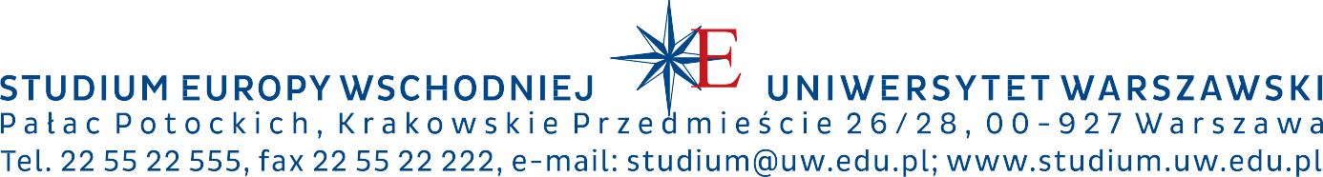
UNIVERSITY OF WARSAW
CENTRE FOR EAST EUROPEAN STUDIES

