CENTRE FOR EAST EUROPEAN STUDIES
UNIVERSITY OF WARSAW

EASTERN
WINTER SCHOOL

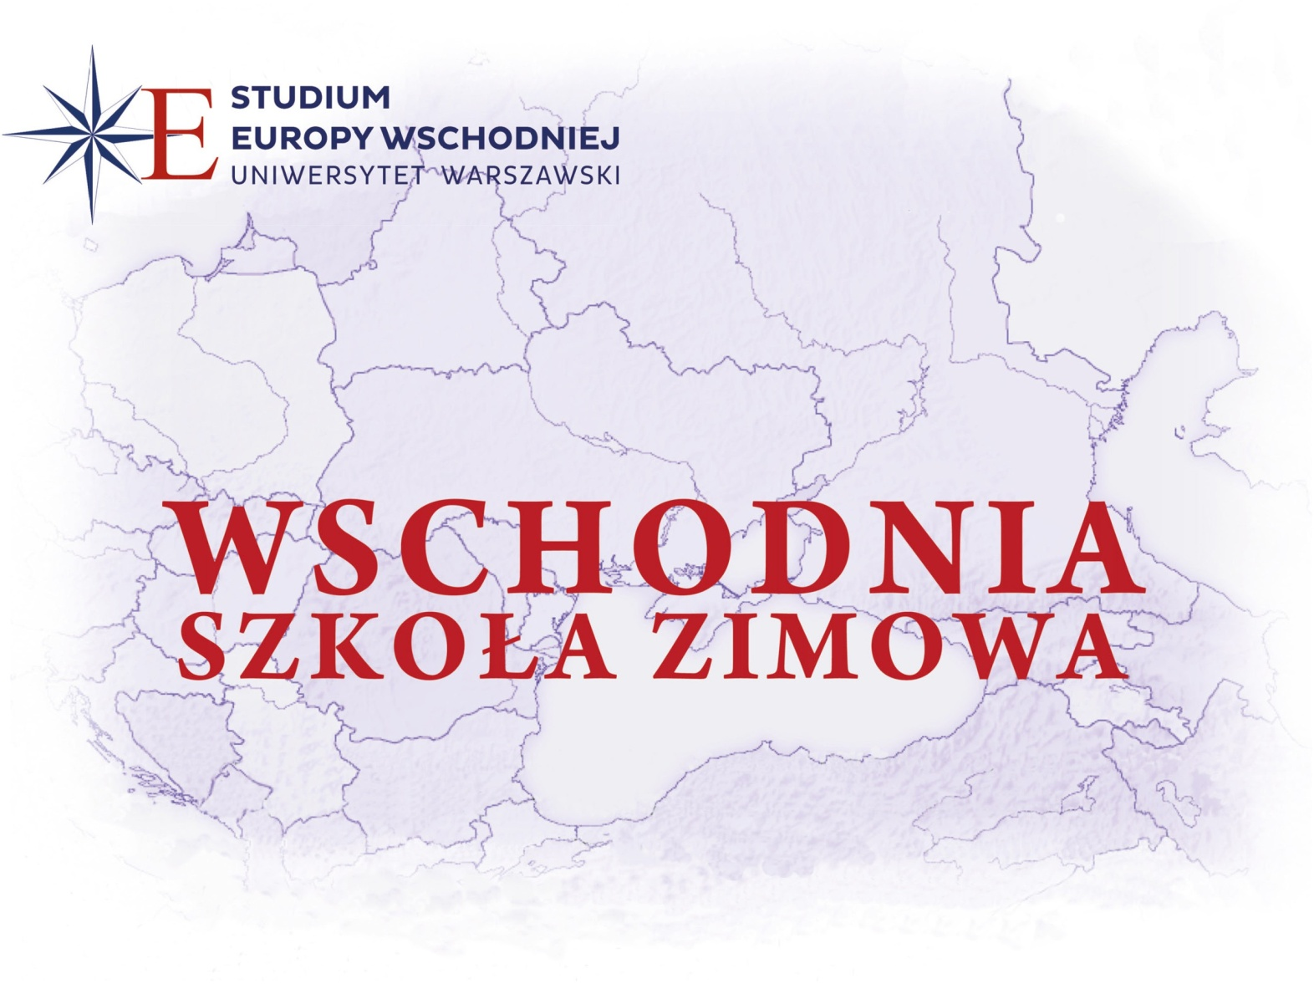
For the last-year students of the humanities who are under 25 years of age and who are preparing their Master's (diploma) theses in the history and present of Central and Eastern Europe (history, political science, international relations, sociology, philology, literature, cultural studies, ethnology, geography, law, economics)

WARSAW

28 FEBRUARY – 14 MARCH 2021

LECTURES AND SEMINARS
- INTERNATIONAL TEAM OF LECTURERS

CULTURAL PROGRAMMES AND MEETINGS

School location:
Centre for East European Studies
Krakowskie Przedmieście 26/28, 00-927 Warsaw

You can apply for participation in the School by 15 January 2021.
If you have any questions, feel free to write at wsl.studium@uw.edu.pl
For more information, visit www.studium.uw.edu.pl

THE EIGHTEENTH
EASTERN WINTER SCHOOL
28 FEBRUARY – 14 MARCH

CONDITIONS FOR PARTICIPATION
  - The school is intended for the last-year students of the humanities who are under 25 years of age (or above, in exceptional cases) and who are preparing their Bachelor's or Master's theses in the history and present of Central and Eastern Europe (history, political science, international relations, sociology, cultural studies, ethnology, geography, law, economics).
  - The School can be attended by learners from Eastern and Central Europe, the Baltic Rim, the Balkans, Russia, Central Asia, the Caucasus and Poland.
  - Candidates are expected to know the Polish language to a degree allowing comprehending lectures and taking advantage of them.
  - The curriculum of the School includes lectures (an international circle of specialists in the region issues will deliver the lectures) and seminars (one out of several seminars to choose from) where every learner of the School will deliver a paper dealing with the field of their diploma thesis. The curriculum also includes visits in institutions in Warsaw and participation in the cultural programme lined with the School.

SCHOLARSHIPS
  - The qualified learners of the School will have their costs of stay at School covered (hotel, board, participation in lectures and seminars as well as accompanying events) and they can apply for co-financing of costs of travel (not applicable to the candidates from Poland and EU countries or people studying in Poland and EU countries).
  - Applications for co-financing of the costs of travel are to be attached to the documents submitted by the candidate.

DOCUMENTS
- At wsl.studium@uw.edu.pl, the candidates are to submit:
  - a completed questionnaire which is available at www.studium.uw.edu.pl,
  - a motivational letter with a proposed topic for the paper,
  - curriculum vitae with a photo,
  - recommendation of the diploma thesis supervisor,
  - confirmation of the Polish language knowledge,
  - certificate from the Dean's office confirming that the candidate is attending the last year of his or her studies,
  - application for coverage of costs of stay at School.
- Full sets of documents are to be sent by 15 January 2021.

QUALIFICATION
- The School's Qualification Board will make decisions on the list of learners by 1 February 2021 and will immediately notify all candidates.
- The formal invitation to the Eastern Winter School 2021 will be sent to the qualified candidates via e-mail by 5 February 2021. The original invitation signed by the headmaster of the School will be sent by traditional mail. The competent consulates of Poland will receive a list of the qualified candidates to make the trip-related formalities easier.
- Arrival of the learners to Warsaw – 27 February. Didactic classes of the School will start on 28 February in Warsaw. Departure of the learners – 15 March.

The School's poster and this folder have been prepared in the Polish language, in the printed and electronic form.
Please distribute the materials widely to all interested parties.
For more information, visit the website of the Centre for East European Studies at the University of Warsaw: www.studium.uw.edu.pl

